SCD July 8th 2020

‘WALL OF DEVELOPMENT’: Light rail plans revealed
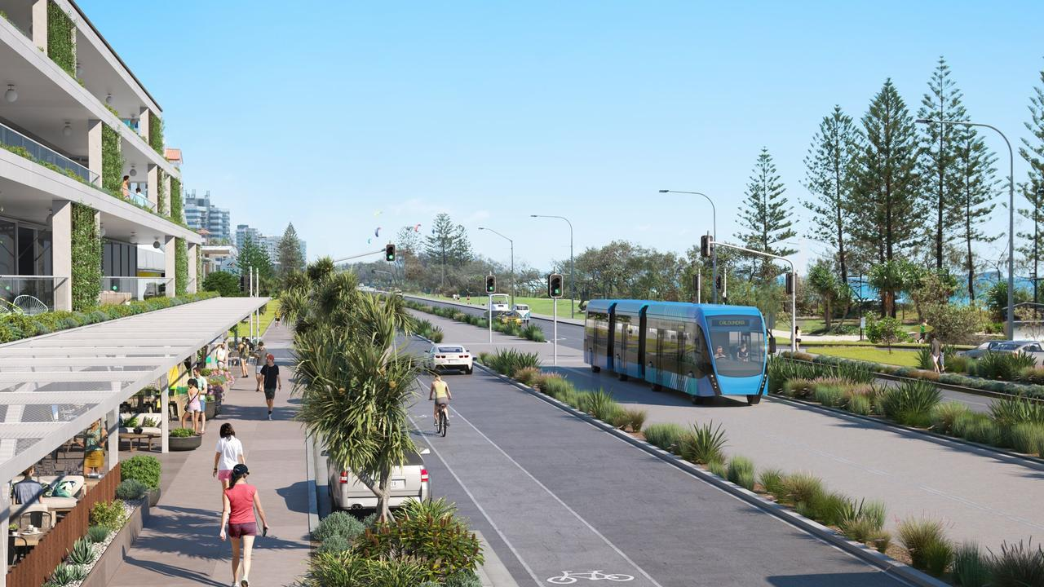
Sunshine Coast Council has revealed concept designs of transport options for the Sunshine Coast Mass Transit Plan.
SCOTT SAWYER
8th Jul 2020 1:15 PM
EXCLUSIVE
A wall of high-density development along the coastal fringe could be headed our way, says Councillor Joe Natoli, if council's mass transit plans steam ahead.
The Division 4 representative revealed council's mass transit plan and transformation strategy involved stations spaced 500m to a kilometre apart, with a 400m radius of high-density development around each station of the Maroochydore to Caloundra stretch.
Sunshine Coast Council Mayor Mark Jamieson has this afternoon responded to Cr Natoli's concerns. His full statement can be read below.
Light rail was understood to be the preferred option, although a business case process was under way exploring a range of options.
Cr Natoli said a recent meeting with council officers and representatives of the Buddina community had shed more light on council's plans, and he felt he had to speak out before he was sworn to secrecy after an official briefing on the project.
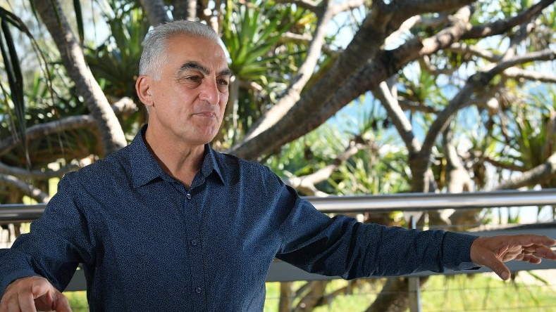
Division 4 Councillor Joe Natoli at Mooloolaba. Photo: John McCutcheon / Sunshine Coast Daily

He said the Coast faced the prospect of "wall to wall" high-density development along some of the major coastal thoroughfares, including Nicklin Way, Brisbane Rd, Alexandra Pde and Aerodrome Rd, if the current plan was progressed.
Cr Natoli said he didn't believe the community would be supportive of a light rail system if they fully understood the trade-off, and questioned why council wasn't engaging with the public already about its plans.
"The public has a right to be told," Cr Natoli said.
He said he understood council was still at least "12 months away" from going to the community, and he feared by then it would be too late, with planning scheme zoning changes being pushed through as the public still tried to understand the plan.
"Be honest with people. Go out and tell them (what the plan is)," Cr Natoli said.
He said he could "see another Gold Coast", with a wall of development along one of the most picturesque strips of the region.
"I'm of the view the public should be told upfront, there should be no surprises," he said.
"Are you prepared to trade away your lifestyle and become another Gold Coast to get a light rail? I think most people would not be willing to accept it.
"This is an absolute game changer compared to what we've got."
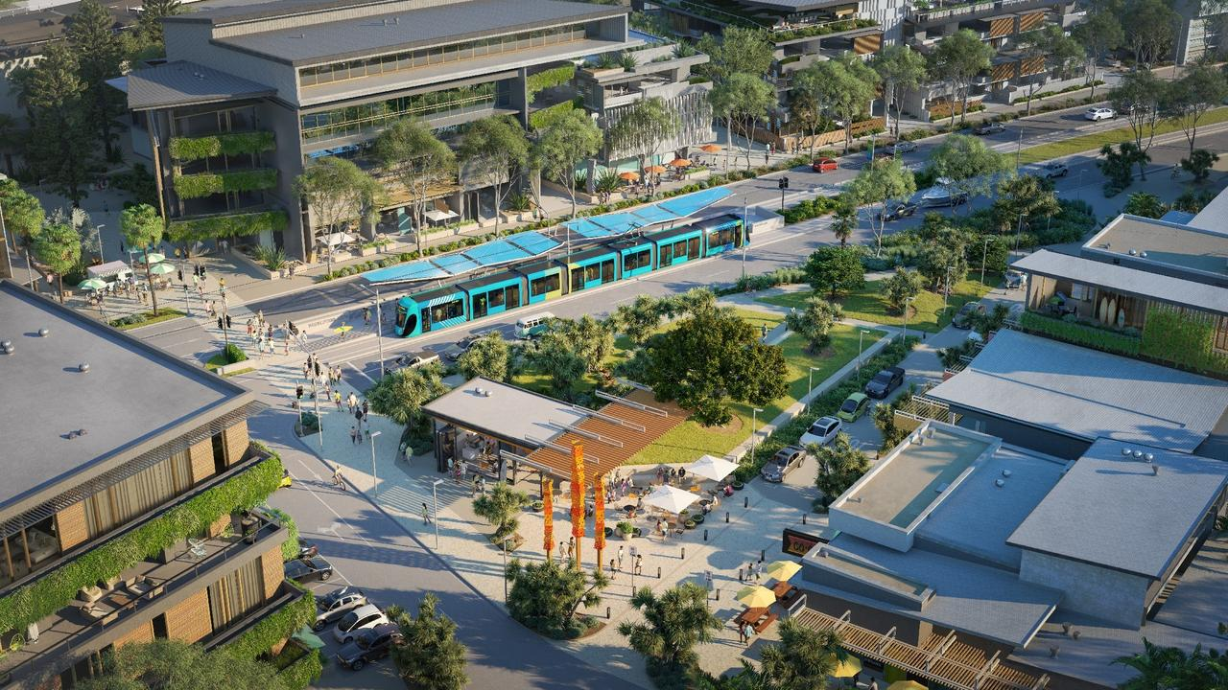
Sunshine Coast Council has revealed concept designs of transport options for the Sunshine Coast Mass Transit Plan.

Cr Natoli questioned the need for it yet, given the current bus network was so under-utilised, and implored the State Government to trial free bus services to see whether there was an appetite for public transport.
He also called on council to stand up to the State Government's growth targets for the region, while major infrastructure was lagging.
He said about 63 per cent of the region's 180,000 new residents were expected to be pushed into infill development along the proposed mass transit corridor.
A strategic business case for mass transit was approved by council in 2019, and a preliminary business case was due to be finished by mid-2020.
A final, detailed business case was due to be completed by 2021.
The Daily reported in January an interim report by PwC which stated the Sunshine Coast Mass Transit Project would be a catalyst for a housing and commercial infill development boom along the coastal fringe.
Stage 1 of the project involved a 30-minute, 13km route from the Maroochydore CBD to the Sunshine Coast University Hospital, with 13 stops along Aerodrome Rd, Alexandra Parade to Venning St, Mooloolaba, Mooloolah River, Nicklin Way and the Birtinya Town Centre.
Speed limits would be capped at 80km/h, to match adjacent roads, with eight services an hour planned.
Stage 2 would involve a nine-stop, 9km link to Caloundra, but this was not explored in detail.
Stage 1 was expected to result in 390,500 less vehicle kilometres travelled in the region in 2041.
"This represents a reduction in vehicle kilometres travelled of approximately 2.4 per cent when compared with the Without-project base case," the report said.
Full statement from Sunshine Coast Council Mayor Mark Jamieson:
Council is not currently considering planning scheme amendments associated with the mass transit solution - and would not be doing so until the business case work is completed in early 2022, the solution has been determined and investment from other tiers of government is confirmed.
Furthermore, all of the information associated with the stages of the business case development that have been developed to date is publicly available.
Council undertook extensive community engagement associated with a potential light rail route in 2014 and will undertake further community engagement as part of the development of the detailed business case.
This has already been made clear previously by council.
The detailed business case development will commence this year.
At the end of the day, public transport is a state government responsibility but council has an important role to play in doing the planning work to encourage the necessary investment by government.
If we do not do so, then there is little likelihood that any substantive and efficient public transport solution will be delivered, in what is the second fastest growing region in the state.
Alternatively, council could sit on its hands and do nothing other than propose simplistic and non-viable solutions that at the end of the day, the State Government would never consider.

