Mass transit 'thought bubble' could destabilise business: MP
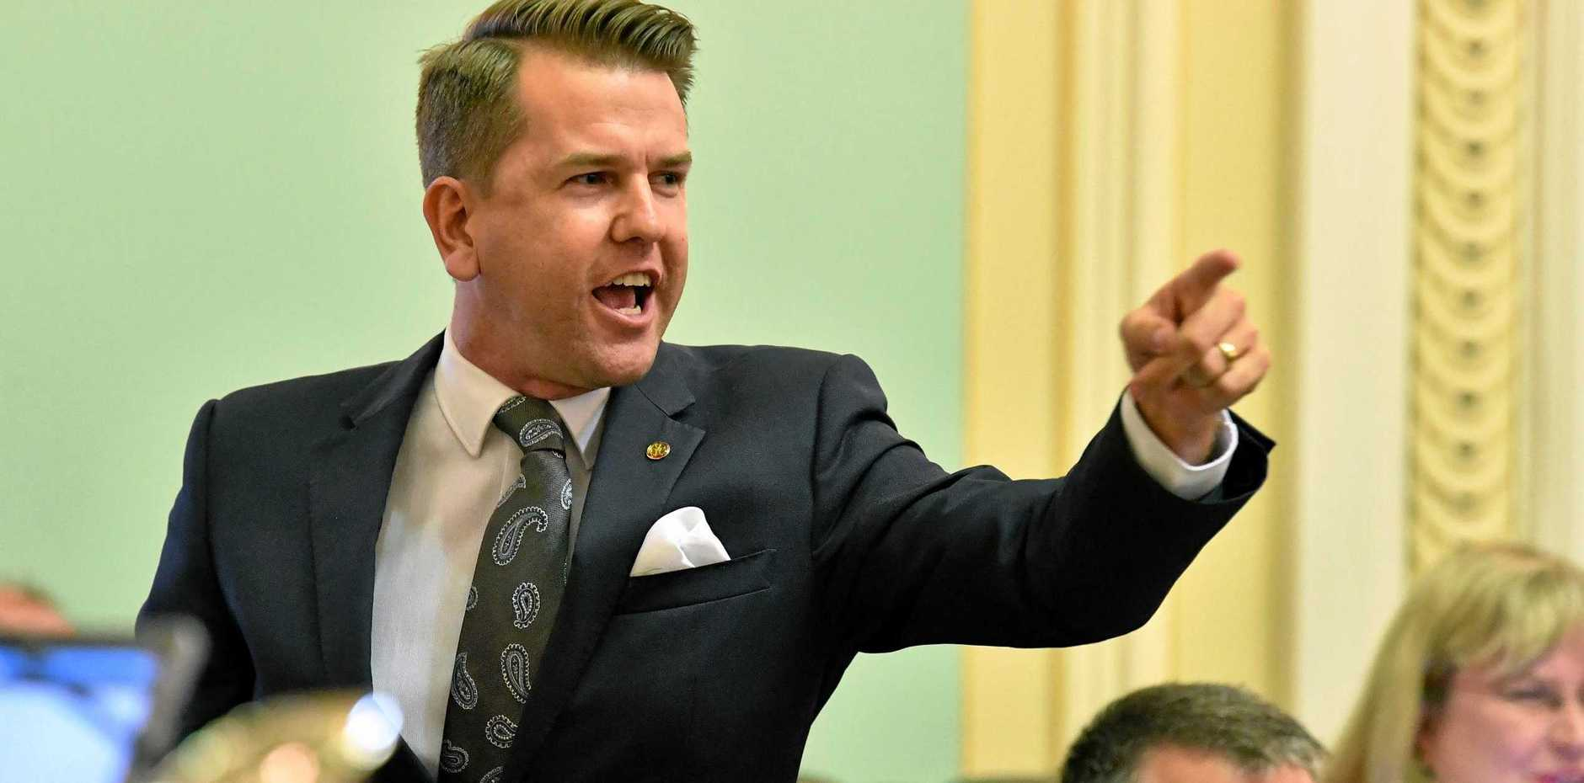
LNP member for Kawana Jarrod Bleijie has questioned the thinking behind a mass transit business case. DARREN ENGLAND
by SCOTT SAWYER
25th Jul 2019 9:57 AM
KAWANA MP Jarrod Bleijie fears a mass transit "thought bubble" could create uncertainty for local investment, businesses and employment.

He made the comments after Sunshine Coast Council released its draft strategic business case for a mass transit system, which earmarked significant infill development along the Nicklin Way, where a possible light rail system could run.
He said it appeared to be a "thought bubble with no information to decipher about what this actually means".
"How many businesses would be displaced? Where do those businesses go and do we just accept that people's livelihoods are taken from them and gifted to a developer?" he said.
"Will residential properties need to be resumed? Again, how many people will lose their homes so council can gift the properties to developers?
"Making these sort of off-the-cuff remarks about shifting, or in effect, closing, commercial businesses along Nicklin Way is dangerous and only serves to create uncertainty for local investment, our local small business community and of course local employment. I would not support that."
Mayor Mark Jamieson said last Friday that heights and densities were still to be considered, and to-date, council has been unable to explain how many people it aims to accommodate along the mass transit corridor, and Nicklin Way, through infill development.
But council has said it wants the first stage of the mass transit system operational by 2026.
Cr Jamieson said it was possible private sector partners could come in to fund the mass transit system, in exchange for land parcels along the corridor for redevelopment.
Mr Bleijie said he believed the best solution to transport issues, particularly along the Nicklin Way, involved critical road infrastructure projects, alongside rail duplication and improved Translink bus services.
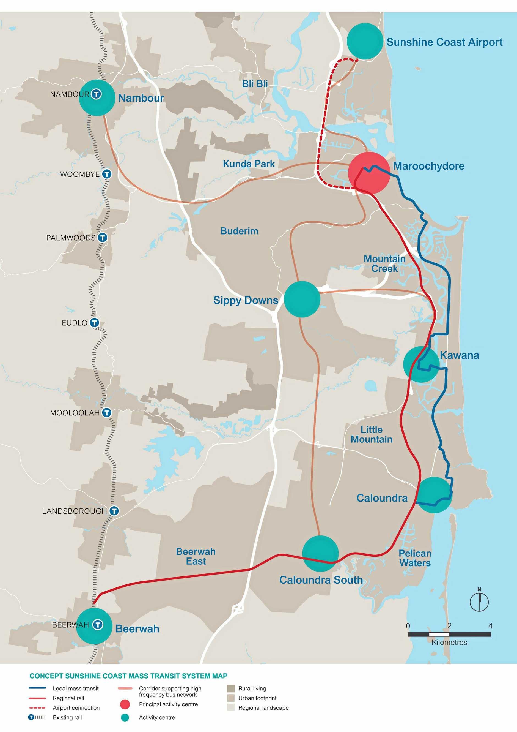
LAYOUT: A concept map of the mass transit system.Contributed
"For starters, we need the Mooloolah River Interchange built," he said.
"This critical road infrastructure is a $440 million project that will significantly ease congestion on Nicklin Way and better connect Caloundra, Kawana, Mooloolaba and Maroochydore.
"It will create a new river crossing, a new direct connection to the Sunshine Coast University Hospital, a new northbound connection from Nicklin Way into Mooloolaba, as well as a new connection on to the Sunshine Motorway."
He said it would significantly reduce travel time on the Nicklin Way and improve capacity.
Kawana Chamber of Commerce vice president Brendon Murray this week said Nicklin Way made sense as the place to bolster densities, as it ran alongside the mass transit corridor.
"We could go higher (residential building heights) there (Nicklin Way), along that strip, without ruining some of the natural beauty right on the coastline," he said on Wednesday.

