ABC Sunshine Coast September 7th 2021
MASS TRANSIT FUTURE TO BE CONSIDERED AT SPECIAL MEETING
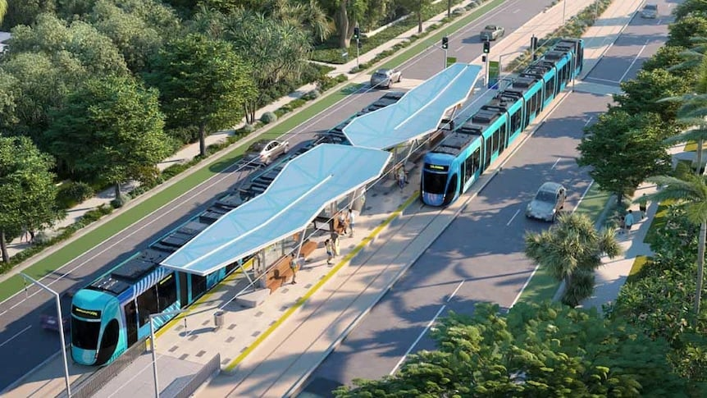

A special meeting of Sunshine Coast Council will be held in the next fortnight where the future of the Mass Transit proposal is expected to be discussed.
Community engagement on council's Mass Transit proposal closed in June and considered several options for an integrated public transport network, including road network upgrades, rapid bus transport and a light rail network.
The Mass Transit Action Group's Greg Smith says the group has been told the final Options Analysis will be discussed by councillors at a special meeting on September the 22nd.

"Will there be enough time to analyse it? I suspect not," he said.

Mr Smith would like to see the community given time to read the final document before it's endorsed to go to the State Government for a detailed business case.

"The community's got to be able to see whether the council has properly taken account of the community response," he said.

In a statement Sunshine Coast Council said the Options Analysis report will be considered at a future council meeting.

"Subject to council’s consideration, the finalised Options Analysis report will be provided to the State and Commonwealth Governments as the basis for the preparation of the Detailed Business Case."

Join our weekly newsletter delivered straight to your inbox | https://www.abc.net.au/connect/ and select ABC Sunshine Coast

